# **Name: Abdurrahman Qureshi**

# **Roll No: 210451**

Practical No: 9

1) Write a Python script to sort (ascending and descending) a dictionary by value.

CODE:

aDict = {"A": 70, "B": 484, "C": 100, "D": 656}  
print(aDict)  
for i in aDict:  
 for j in aDict:  
 if aDict[j] > aDict[i]:  
 temp = aDict[j]  
 aDict[j] = aDict[i]  
 aDict[i] = temp  
print(aDict)  
for i in aDict:  
 for j in aDict:  
 if aDict[j] < aDict[i]:  
 temp = aDict[j]  
 aDict[j] = aDict[i]  
 aDict[i] = temp  
print(aDict)

OUTPUT:

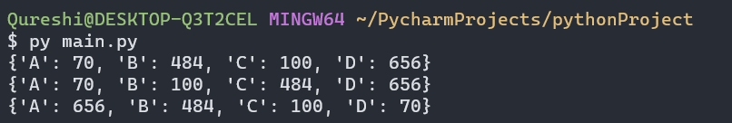

2) Concatenate two dictionaries

**CODE:**

aDict = {"A": 70, "B": 484, "C": 100, "D": 656}  
bDict = {"A": 470, "B": 4848, "C": 1090, "D": 6056}  
print(aDict)  
print(bDict)  
print(aDict, bDict)

**OUTPUT:**

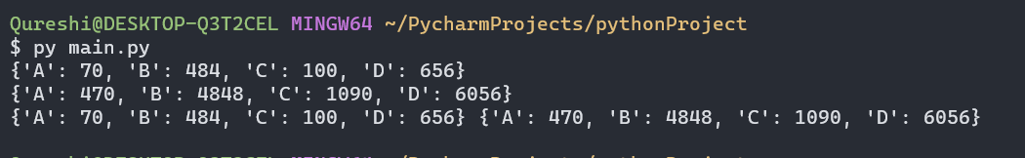

3) Combine two dictionaries adding values for common keys.

**CODE:**

aDict = {"A": 70, "B": 484, "C": 100, "D": 100}  
bDict = {"A": 70, "E": 4848, "Q": 1090, "D": 100}  
print(aDict)  
print(bDict)  
dict3 = {}  
for key in aDict:  
 if key in bDict and key not in dict3:  
 dict3[key] = aDict[key] + bDict[key]  
print("New dictionaries:")  
print(dict3)

**OUTPUT:**

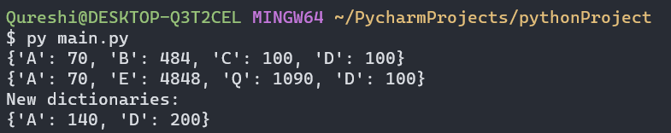

4) Print all unique values in a dictionary.

**CODE:**

bDict = {"A": 470, "B": 4848, "C": 1090, "D": 6056}  
print(bDict)  
print(bDict.values())

**OUTPUT:**

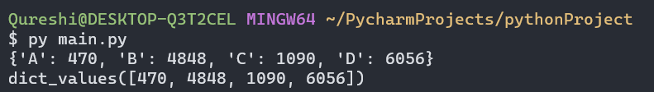

5) Find the highest 3 values in a dictionary.

**CODE:**

bDict = {"A": 470, "B": 4848, "C": 1090, "D": 6056}  
print(bDict)  
sortedDict = sorted(bDict.values(), reverse=True)  
first = sortedDict[0]  
second = sortedDict[1]  
third = sortedDict[2]  
print(first)  
print(second)  
print(third)

**OUTPUT:**

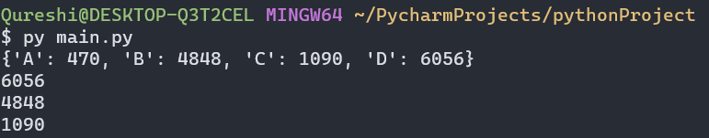

EXTRA QUESTIONS

6) Create a dictionary, copy it into a new one, and clear the original dictionary.

**CODE:**

bDict = {"A": 470, "B": 4848, "C": 1090, "D": 6056}  
print(bDict)  
cDict = bDict.copy()  
bDict.clear()  
print(bDict)  
print(cDict)

**OUTPUT:**

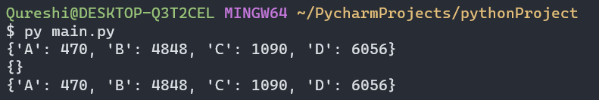

7) Retrieve the value of a specified key from a dictionary.

**CODE:**

bDict = {"A": 470, "B": 4848, "C": 1090, "D": 6056}  
print(bDict)  
myKey = input("Enter dict key: ")  
if myKey in bDict:  
 print(bDict[myKey])  
else:  
 print("NOt present")

**OUTPUT:**

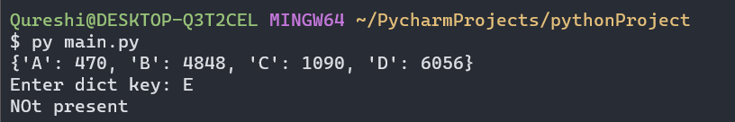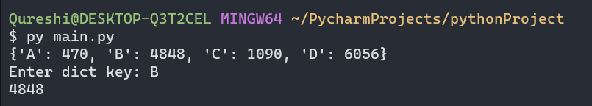

8) Return a list of keys in a dictionary.

CODE:

bDict = {"A": 470, "B": 4848, "C": 1090, "D": 6056}  
print(bDict)  
myList = bDict.keys()  
print(myList)

**OUTPUT:**

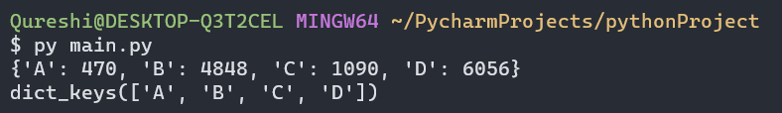

9) Return a list of values in a dictionary.

**CODE:**

bDict = {"A": 470, "B": 4848, "C": 1090, "D": 6056}  
print(bDict)  
myList = bDict.values()  
print(myList)

**OUTPUT:**

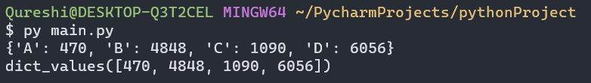

10) Remove specified key

**CODE:**

bDict = {"A": 470, "B": 4848, "C": 1090, "D": 6056}  
print(bDict)  
myKey = input("Enter key: ")  
del bDict[myKey]  
print(bDict)

**OUTPUT:**

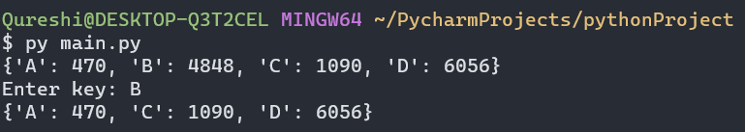

11) Update dictionary with specified key-value.

**CODE:**

bDict = {"A": 470, "B": 4848, "C": 1090, "D": 6056}  
print(bDict)  
myKey = input("Enter key: ")  
myVAl = input("Enter value: ")  
bDict[myKey] = myVAl  
print(bDict)

**OUTPUT:**

